ECE241 – FINAL REPORT

**SLOT MACHINE**

The quality and success of a project is often measured by its ability to meet expectations, specifications and needs. When it comes to deciding the project idea, many people are quick to believe that quality implies difficulty – a good project depends on complexity. As the final project of ECE241, my partner and I sought to make our project idea unique, fancy while maintaining a moderate level of difficulty that is within our scope of ability developed through the course.

Our first objective in creating our idea was to incorporate as much of what we learned throughout the course into our project as possible to demonstrate our firm understanding of class materials. Next was to make the idea interesting and eye-catching. We started by viewing some of the past projects through the links on piazza to gather inspiration and to witness the elements that make a project captivating. We took note of the key visuals, colors and animations of some remarkable creations. Eventually we agreed upon a game that everyone is familiar with: slot machine game. It is a simple yet addicting game that has brought people around the globe to play in casinos. It is a game that would embody everything we learned in ECE241 from adders to FSM as well as the potential to have stunning visuals to be produced on the VGA display – a type of fanciness unique to slot machines. The idea stood out to us and we were genuinely excited to start the project. This became our motivation to make this project as good as we imagined.

Although we were mostly content with the final product of our VGA game, there are minor things that we could have done differently. If there is one thing that stands out about casino games, it is the noise, music and the sound of coins that makes you feel like you won something big! Slot machines are perhaps the best representation of it all. While we did attempt to implement audio files into our game and the FPGA, we were not able to get it to work. Unfortunately due to time constraint and more important issues, the idea did not make it into the final game. This is certainly one of our biggest regrets and something we would have loved to have.

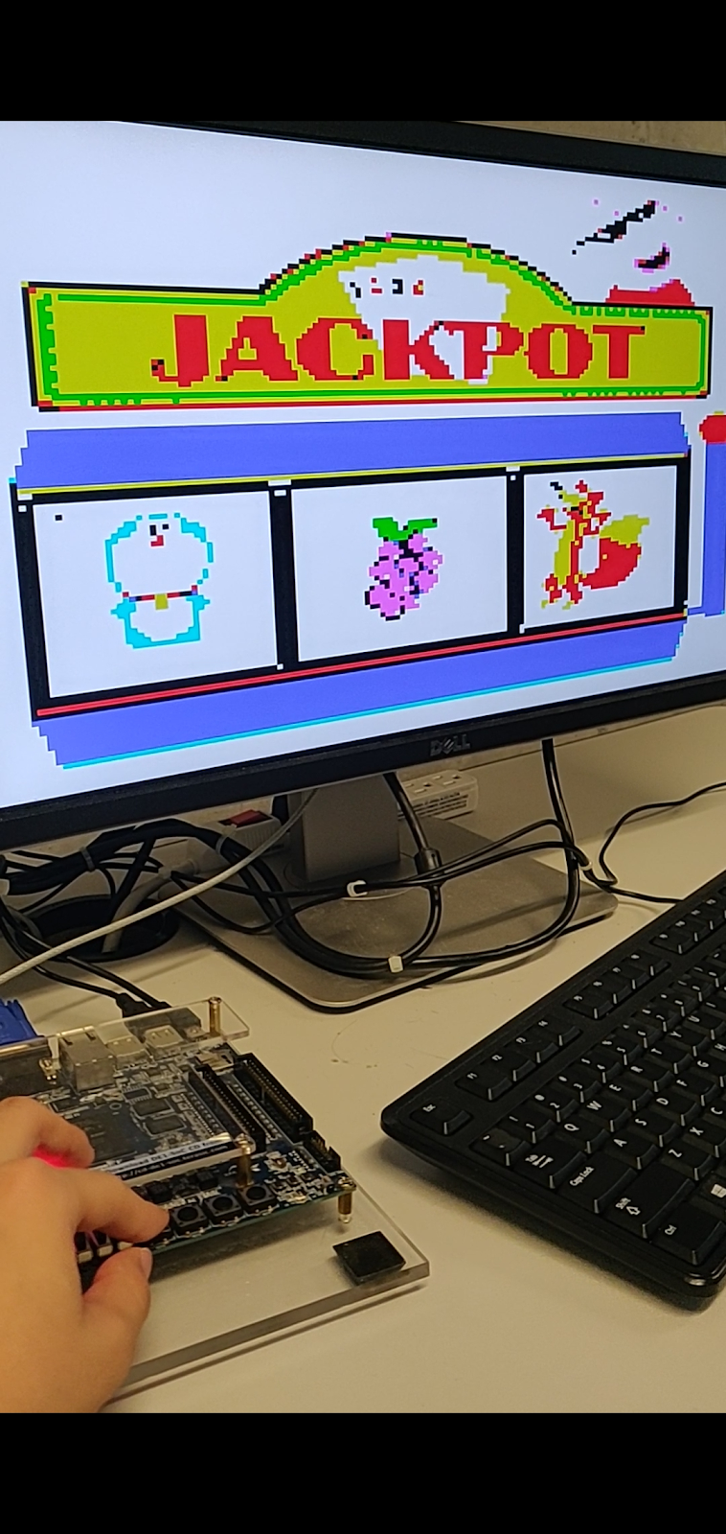

Notice the **trailing pixel** on the top left corner.

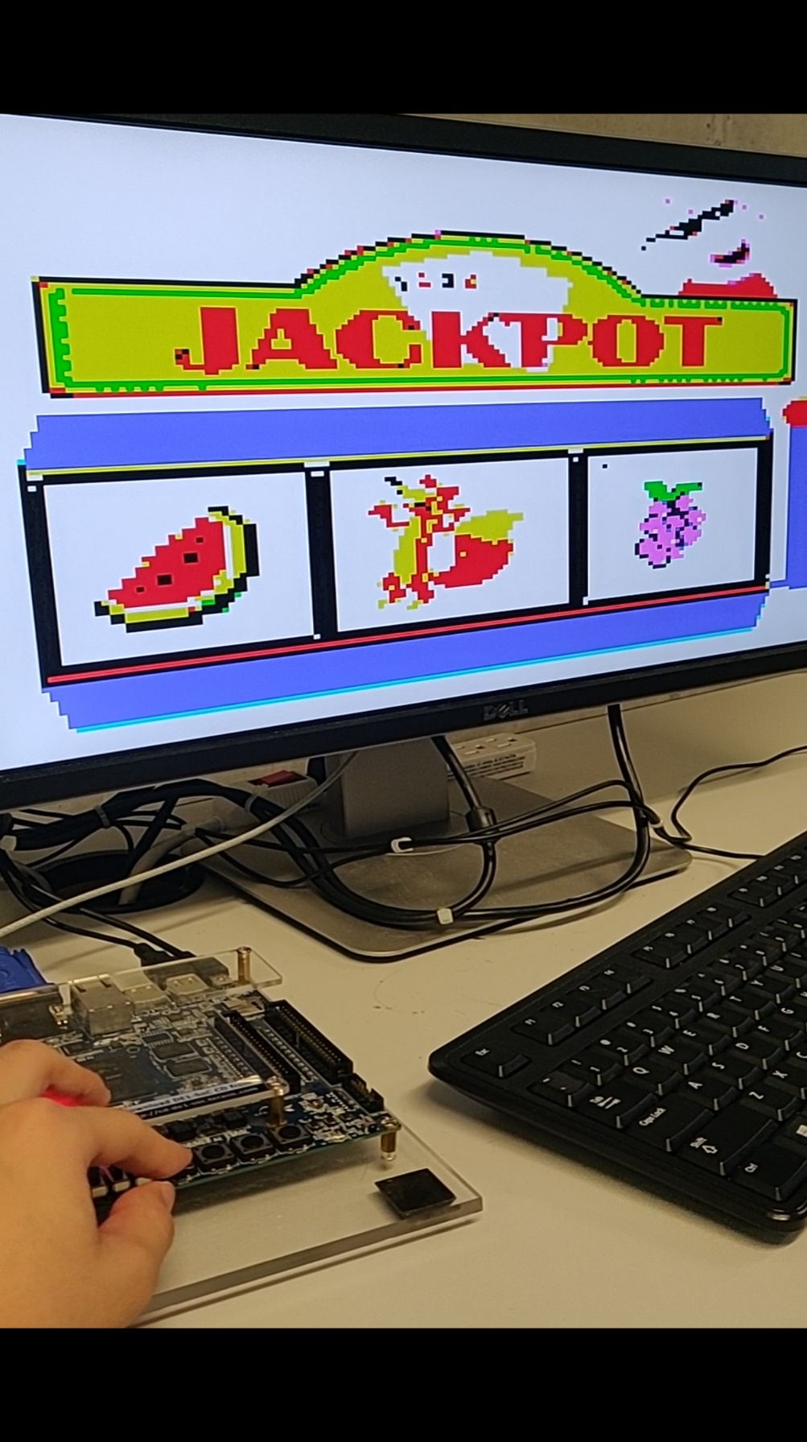

In both instances, the extra pixel appeared on images loaded **AFTER** the fox.